

Practices for Secure Software Report

Table of Contents
Document Revision History 3
Client 3
Instructions 3
Developer 4
1. Algorithm Cipher 4
2. Certificate Generation 4
3. Deploy Cipher 4
4. Secure Communications 4
5. Secondary Testing 4
6. Functional Testing 4
7. Summary 4
8. Industry Standard Best Practices 4

Document Revision History

Version | Date | Author | Comments
1.0 | 04/19/2026 | Jose Brindas | Initial version of SSL-enabled application with dependency-check analysis and testing completed

Client



Instructions

Submit this completed practices for secure software report. Replace the bracketed text with the relevant information. You must document your process for writing secure communications and refactoring code that complies with software security testing protocols.

- Respond to the steps outlined below and include your findings.
- Respond using your own words. You may also choose to include images or supporting materials. If you include them, make certain to insert them in all the relevant locations in the document.
- Refer to the Project Two Guidelines and Rubric for more detailed instructions about each section of the template.

Developer
Jose Brindas

Algorithm Cipher

The recommended cryptographic algorithm for this application is SHA-256 for checksum generation and RSA for the SSL certificate used to support HTTPS communication. SHA-256 is a secure hashing algorithm that produces a fixed-length 256-bit hash value, which makes it useful for verifying data integrity. In this project, SHA-256 was used to generate a checksum for the message “Hello World Check Sum!” so that the application could verify whether data had been changed or tampered with. RSA was used during certificate generation to support secure key exchange and encrypted communication over HTTPS. Together, these algorithms help protect sensitive financial data by supporting confidentiality and integrity.
Hash functions such as SHA-256 are one-way functions, meaning the original data cannot easily be derived from the hash value. The 256-bit output provides stronger protection than older algorithms such as SHA-1 or MD5, which are no longer considered secure for modern applications. In secure communication, both symmetric and asymmetric encryption play important roles. Symmetric encryption uses the same key for encryption and decryption and is generally faster, while asymmetric encryption uses a public and private key pair. RSA is an asymmetric algorithm, which makes it useful for certificate-based security and secure key exchange. Random values and secure keys are also essential because predictable keys weaken security. Over time, encryption standards have improved as older algorithms became vulnerable, so using modern approaches such as SHA-256, RSA, and HTTPS reflects current security best practices.

Certificate Generation
Insert a screenshot below of the CER file.

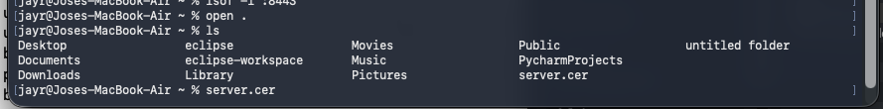

Deploy Cipher
Insert a screenshot below of the checksum verification.

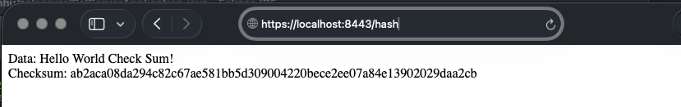

Secure Communications
Insert a screenshot below of the web browser that shows a secure webpage.

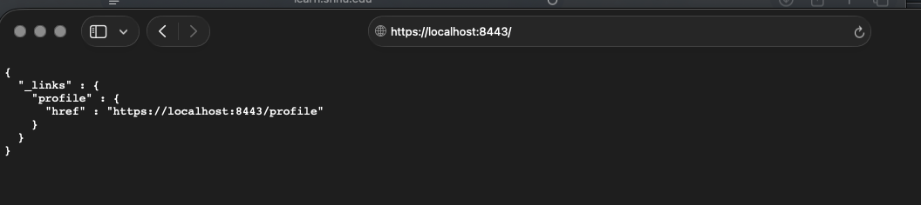

Secondary Testing
Insert screenshots below of the refactored code executed without errors and the dependency-check report.

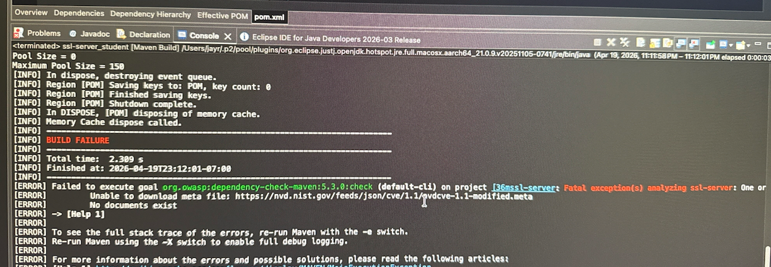

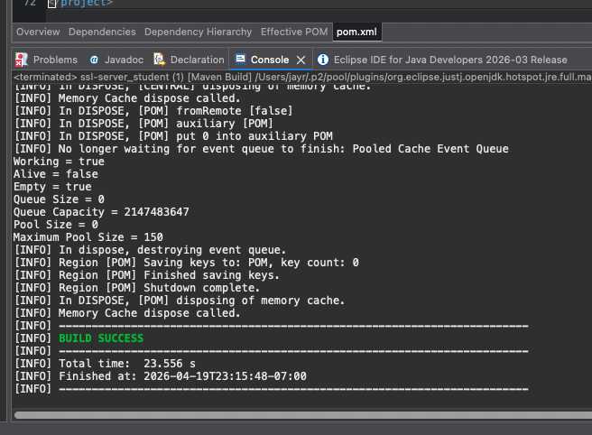

Functional Testing
Insert a screenshot below of the refactored code executed without errors.

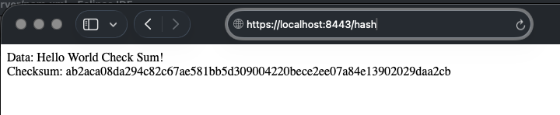

Summary

This project involved refactoring the application to improve its overall security by enabling HTTPS and implementing secure communication using a self-signed SSL certificate. By configuring the keystore and updating the application properties, the server was able to run securely over port 8443. After resolving initial setup issues, the application successfully executed without errors, and the /hash endpoint was verified to correctly generate a checksum for the provided data. Additionally, the OWASP dependency-check tool was used to scan the project for known vulnerabilities. Although there were some initial connection issues when retrieving vulnerability data, the build ultimately completed successfully. Overall, the application now demonstrates improved security and proper functionality.

Industry Standard Best Practices

Several industry standard best practices were applied in this project to strengthen application security. Enabling HTTPS ensured that all data transmitted between the client and server is encrypted, protecting it from potential interception. The use of a keystore to manage SSL certificates reflects a common and secure approach used in real-world applications. Additionally, the integration of the OWASP dependency-check plugin helps identify known vulnerabilities in project dependencies, allowing developers to address potential risks early. Following secure coding practices, such as properly managing configuration files and avoiding exposure of sensitive information, further enhances the application’s security. These practices align with industry expectations for building secure and reliable software systems.

